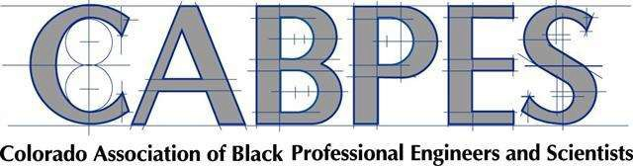
PO Box 200508 - Denver, CO 80220
303.329.6251 Office
cabpes@gmail.com www.cabpes.org

STUDENT SUMMMER APPLICATION FORM
2021 – 2022
(please type or print legibly)

Student Information – Please select the program(s) you want to take:
___Summer Math Quest _ Books and Beyond
Last Name |  | Middle Initial | First Name (No nicknames)
Parent(s)/Guardian’s Name |  | Relationship to Student: | Student Grade/Age  /
Home Address |  | City/State/Zip Code
High School Students’ Check Math Subject:  Algebra__ Trigonometry____  Geometry__ Calculus __ |  | Parent’s Cell Phone #
Child’s Date of Birth  / / | Today’s Date  / / | Parent E-mail Address
Please answer the following questions.

- How did you hear about CABPES?

- What other STEM programs have you participated in or are currently enrolled in?

- Are you interested in other CABPES programs and events If yes, please put an X next to the program(s) or event(s) you are interested in.
Math Enrichment Program (MEP) Junior Engineers, Tomorrow’s Scientists (JETS)
SAT/ ACT College Preparatory Program Parental Action Committee for Education (PACE)
STEM Career Fair Table Talks: An Intimate Event Series

